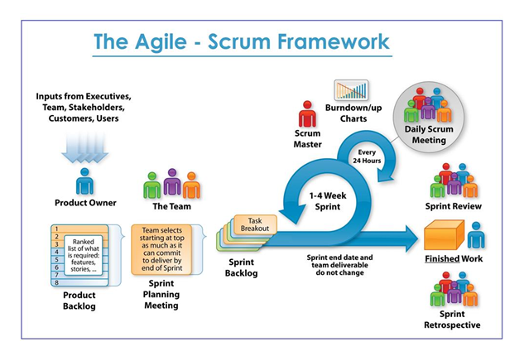

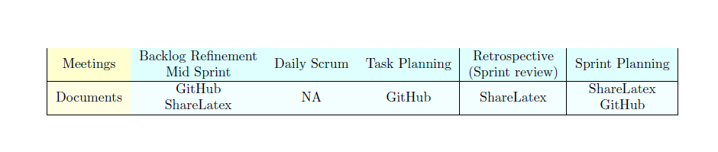

Story cards & Visible wall

<https://github.com/Artibot/Autonomous-Car-CHEBB/projects/1>